**NATIONAL INSTITUTE OF TECHNOLOGY CALICUT**

**DEPARTMENT OF ELECTRONICS AND COMMUNICATION ENGINEERING**



**EC 4091: DIGITAL SIGNAL PROCESSING LABORATORY**

MINI PROJECT

Brick Wall (Ideal LPF)

Date: 10-10-2018

**Submitted by:**

B.VedaSree - B150734EC

B.Sravani - B150783EC

Ch.Priyanka - B150837EC

Ch.Vamsi - B150530EC

**AIM:**

To design idea Low pass filter.

**THEORY:**

**Ideal LPF:**

The filter's impulse response is a sinc function in the time domain, and its frequency response is a rectangular function. It is an "ideal" low-pass filter in the frequency sense, perfectly passing low frequencies, perfectly cutting high frequencies; and thus may be considered to be a brick-wall filter.

**FIR Filter:**

A Finite impulse response filter is a filter whose impulse response is of finite duration. This is in contrast to IIR filters whose impulse response is of infinite duration.

**FIR FILTER DESIGN USING WINDOWING:**

Consider an ideal low pass filter with impulse response H(w) and cut-off frequency wc

H(w) = 

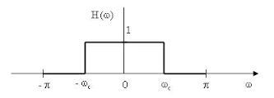

The impulse response of this ideal low pass filter is



* The impulse response is an sinc function which is infinite and non causal. Hence, it cannot be implemented practically. So, we shift the impulse response and truncate it by applying a suitable window. By truncating it we allow certain approximation error.
* If h_ideal[n] is the impulse response of ideal filter and w[n] is the impulse response of window, then h_designed[n] = h_ideal[n]. w[n]
* Since time domain multiplication implies frequency domain convolution, the frequency response of designed filter will be convolution of ideal frequency response with the frequency response of window. Hence the designed filter will have some ripples in pass band as well as stop band.
* Different windows like Rectangular window, Bartlett window, Hann window, Hamming window etc., can be used for windowing. The choice of window is based on the stop band attenuation or other specifications.

**CODE:**

close all, clear all;

fs = 8000;

ws = 1150*2*pi/fs;

wp = 1000*2*pi/fs;

wc = 0.5*(wp+ws);

tb=(ws-wp)/2; %transition bandwidth

N=(8*pi)/tb;

N=ceil(N);

h=zeros(1,N);

for n=1:N

h(n)=sin(wc*(n-ceil(N/2)))/(pi*(n-ceil(N/2))); %impulse response of LPF

end

h(ceil(N/2))=wc/pi;

n=1:N;

for i=1:N

w(i)=0.54-0.46*cos(2*pi.*i/(N-1)); %Hamming window

end

hw=(h.*w); %windowing

figure

stem(hw);

xlabel('n');

ylabel('h[n]');

title('Impulse response of low pass filter after windowing');

fvtool(hw);

**PLOTS:**

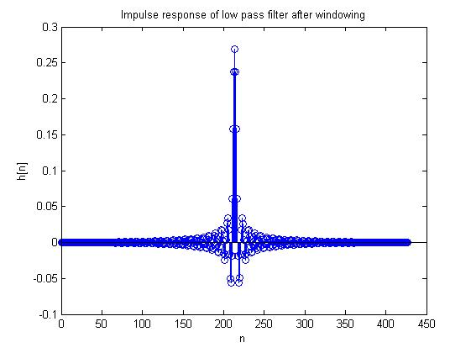

**LPF magnitude response:**

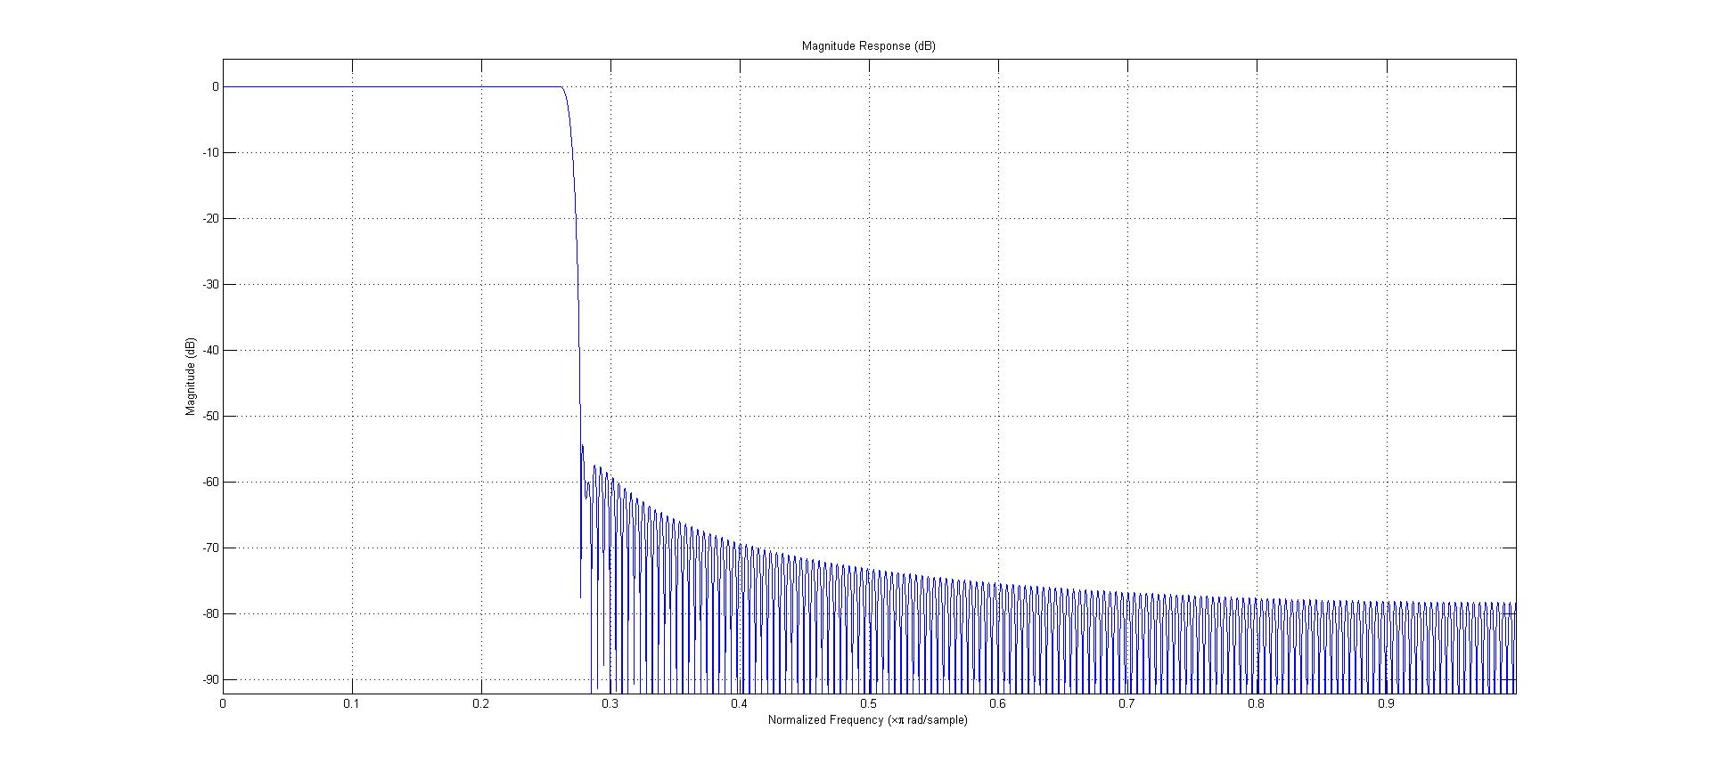

**RESULT:**

Designed the ideal Low pass filter using hamming window.